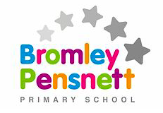

Welcome to Year 3 2020/21!

Hello and welcome to Year 3. We know that it has been a long time since we were all in school together and we are looking forward to seeing all of you again. There have been lots of changes in school to make sure we are all safe. Try not to worry. Sharing this document with your parents will help you to prepare for your first few weeks back in school. All of the staff will be here to help you and make sure that you are able to do your very best. If you have any questions you can use the “submit your work” page on the year 3 section of our school website and we will do our very best to answer them for you.

Meet the staff
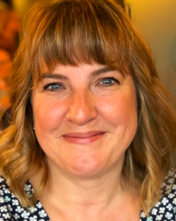
Miss Rollinson 3R Mrs Downing 3DE Mrs Edgar 3DE
Hello year 3. I share 3DE with Mrs Downing. My favourite subjects are Singing and Music
Hi year 3. I can’t wait for September. My favourite subjects are Reading and English. Oh and did I mention Reading?
Hi Year 3. I am really looking forward to seeing you all soon. You will notice that I have quite a big bump as I am having a little girl in October. My favourite subject is Maths.

Also joining us in year 3 will be Mrs Broom (yes we have 2 of them) and Miss Fitzer. They will be supporting all of you in your learning alongside your class teachers.
Hi year 3. I am really looking forward to working with you all. My favourite subject is P.E. and I love to cook.
Mrs Writtle

Our Year 3 classrooms.

As you can see by the pictures, our classrooms have changed a little. You will be sitting in pairs. However, we can all see and hear each other and our teachers will be able to help and support all of us.

What our learning will look like in year 3

In the first couple of weeks back, we will all be very busy finding out what we know in all of our subjects. We will spend time making sure that all of us are okay in school and that we understand and can follow the new routines. We will be doing a lot more handwashing to help us be safe and healthy. You will find a poster on handwashing at the end of this document.
Maths
You will be learning all about numbers up to 1,000. This will include looking at what the numbers mean in a 3-digit number. You will also be counting in 2s, 3s, 4s, 5s, 8s and 10s.

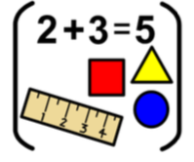

In year 3 our times tables are very important.
We will be learning the times table facts for the
x2, x5, x10, x3, x4 and x8 times tables.

Reading
In reading we will be using the VIPERS to help us understand and talk about books. The VIPERS stand for Vocabulary, Infer, Predict, Explain, Retrieve and Summarise.

Our first class book this year is…

Writing
In writing we will be learning how to write a narrative. We will be thinking out story settings and characters and adding speech to our stories. Then later we will be looking at writing letters and diary entries.

In year 3 phonics will still be very important in helping us to read and write words and sentences. However we will also be looking at SPaG. SPaG stands for Spelling Punctuation and Grammar. We will be learning how better word choices can improve our work and how to use them. We will also be learning how to use new things in our work such as inverted commas, word families and tenses.

Science Geography SMSC
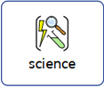
You will be learning all about yourself and your feelings
You will be learning all about forces and magnets. This means that you will be using magnets to see what they attract and repel. You will also be seeing how objects move differently on a range of surfaces.

Our topic in the first half term is all about settlements.
You will learning to use maps, atlases and compass points. You will be learning about towns, cities and villages and what people do there

Art R.E

You will be learning about painting. We will be exploring watercolours and looking at the work of Claude Monet

You will be learning about Sikhism and some of their festivals of celebration.

We are really excited about the learning we are going to be doing in year 3. There will be a lot of new things to learn and explore and it is going to be lots of fun! Keep reading for more information…….

A Typical year 3 day

In September our school day will start at 8.40. You will come into school through the gate at Bromley, where Dave stands, then line up on the playground and your teacher will meet you and bring you into class. Whoever brings you to school can bring you to your line before they leave through the same gate. You will come in and wash your hands/use hand sanitiser. You will have your own coat peg and your own seat in class. This will be your seat only. Your school day will finish at 3.20. We will use hand sanitiser on the way out and then your teacher will walk you out to meet your parents at the gate.

A typical day might look like this:
- Daily reading and register
- Lesson one – Maths
- Break
- Lesson two – Guided Reading
- Lesson three – English
- Lunch
- Reading and reflection
- Lesson 4/5 – Humanities and Creative arts
- End of the day story

And don’t forget HOMEWORK!

Homework will be set weekly. This will be either English or maths. You are expected to complete this and hand it in. A parent at home can help you to do this – we do not expect you to do it on your own.

To help support your learning in school you should:
- Be reading at home with an adult – at least 3 times per week.
- Practicing any times tables or spellings given to you.
- Completing homework with an adult to help you if you need it.

Finally…. We all know how important it is to stay safe and healthy. One of the ways we will be doing this at school is to wash our hands regularly. There is also a hand sanitiser station in every classroom. We will be asking the children to wash their hands at lots of times during the school day

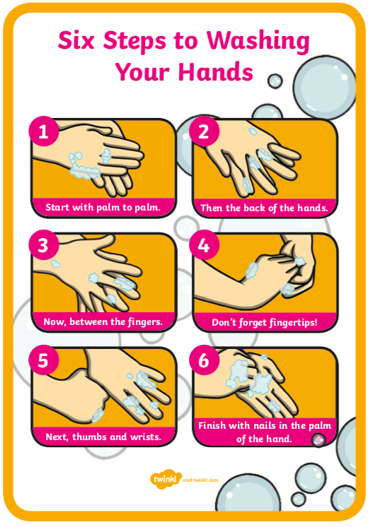
See you soon year 3.

