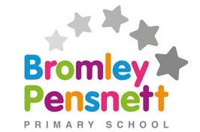
Nursery Class 2020/21
Welcome to Nursery 2020/21! We know that some of you may be slightly anxious about sending your children back into school; however we will be doing everything possible to ensure our new Nursery classroom is as safe, welcoming and positive as possible for all of our new and returning children!
Your teachers this year will be Miss Dumper and Mrs Woodward. We are so excited to meet you all and learn and grow together! If you ever have a problem or need help with anything at all, we will always be nearby to help you out!
Miss Dumper Mrs Woodward
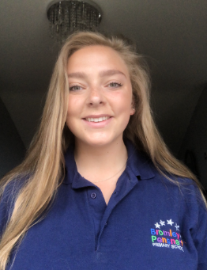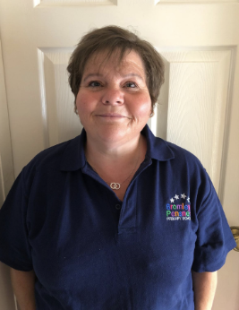

Our Classroom
Our Nursery classroom is in a different place to last year. This year children will enter the classroom from the main playground area through the small wooden gate that leads to our small outdoor space with our water, sand and music areas.
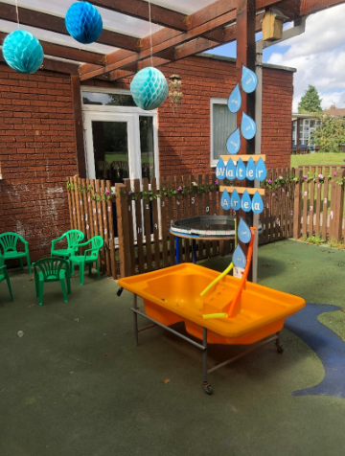
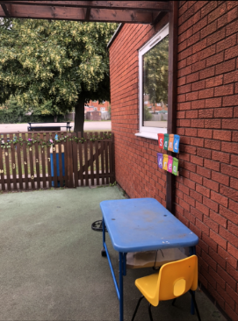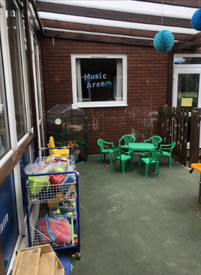
Our aim this year is to really make use of this great space as it has a cover over the top so it can be used in all weathers! This area has lots of fun things to choose from including animals, drums, balls and bottles to use in the water and sand.

Arts, Crafts and Creating Area
In this area children will be able to make, build and paint anything they like with lots of different materials.
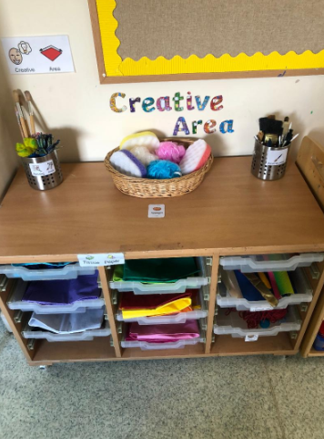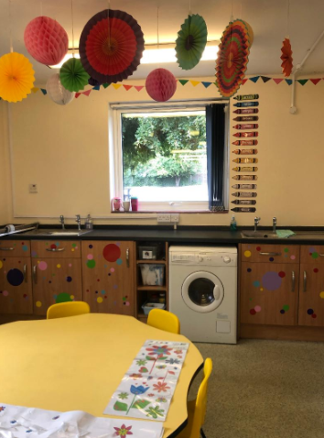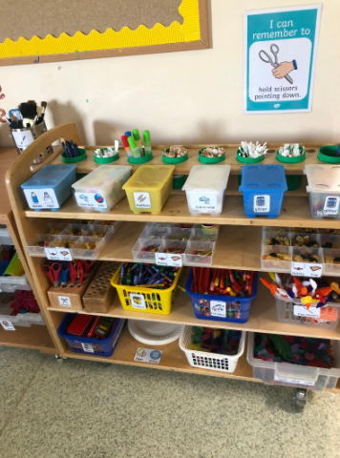

Role Play Area
When children come into school, the role play area will be set up as a Doctors Surgery, this will be part of our ‘all about me’ topic.
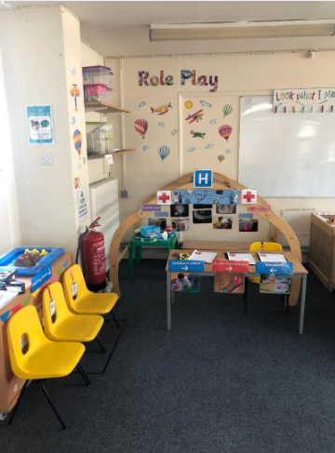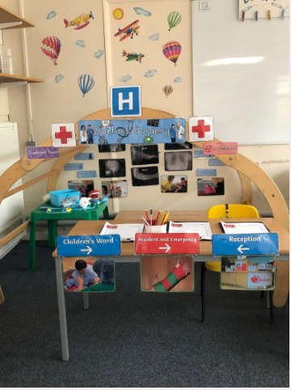
Library Area
In our new class we have transformed a separate room into a quiet library and reading area. We are so excited to have this space to share stories with friends and small groups.
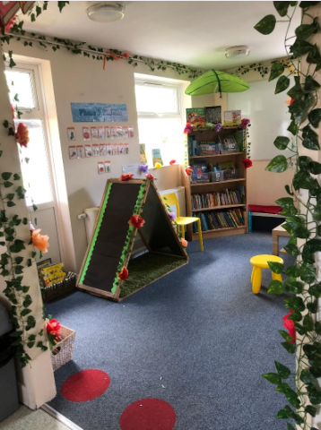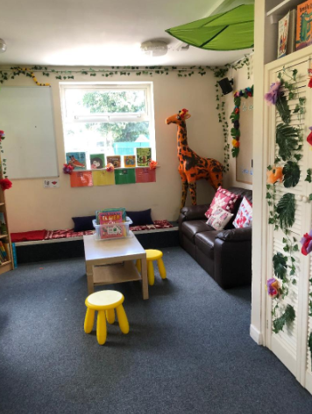
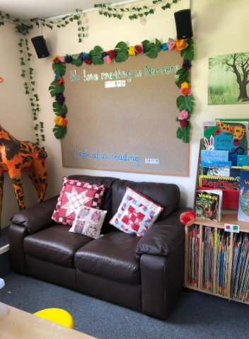

Construction Area
Our construction area is ready for children to build using wood, Lego and Duplo blocks. This is great for their gross motor skills! We also have a train table and lots of train tracks for children to build with too!

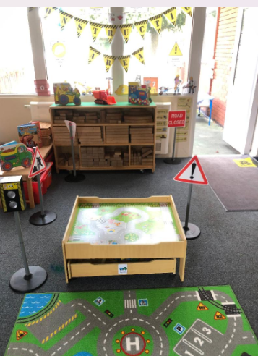

Literacy and Mark Making Area
This area will be where children can focus on drawing things using fine motor skills. We have a range of tools to use when mark making including felts, chalks and crayons. We also have a variety of different paper choices for children to use for cutting and sticking activities. This area also has a chalk board on the wall for children to use freely, they may enjoy this as well as it being great for their core strength to write vertically. We also have a shallow sand pit for children to draw, make patterns and practice letters in!


