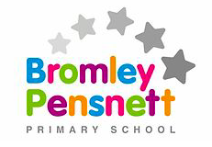

Welcome to Year 6 2020/21
Hello and welcome to Year 6. It has been a long time since we have all been together in school and we are really looking forward to seeing you all again. To accommodate for your return there have a been a few changes to the school, all of which have been made to ensure that we are all as safe as possible when we return. I have put together this document to give you an outline of what to expect when we return in September. If you have any questions or queries, do not be afraid to get in touch and we shall do our best to answer them.
Mr Lord
Staff
Mr Lord Mrs Grover Mrs Crew
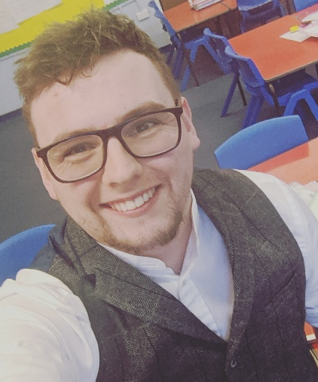
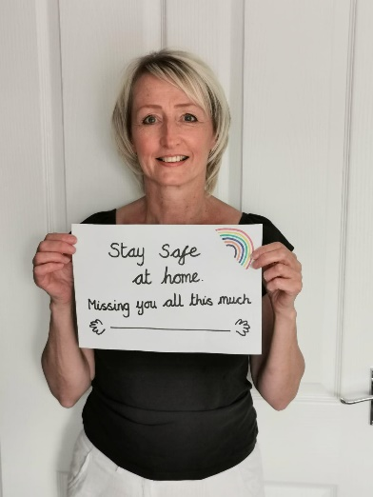

Our Classroom
Below are some pictures of our classroom. As you can see, they are different to what you are used to. However, it has been set out to ensure that we can all participate fully during lessons.

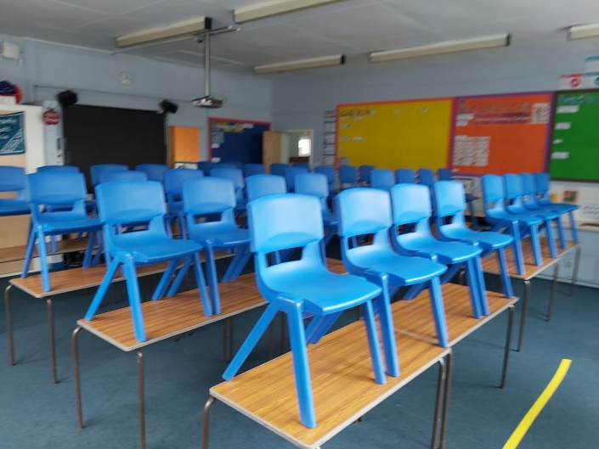
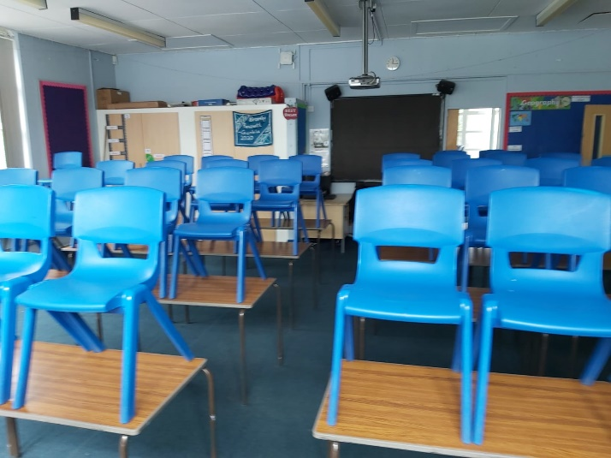
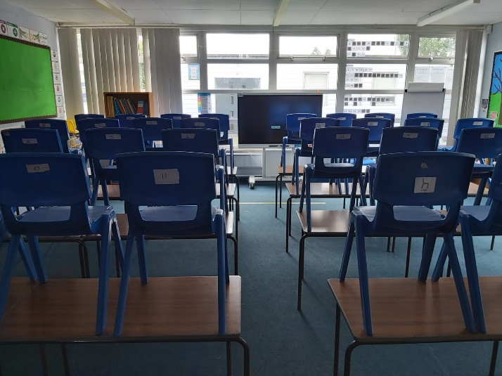
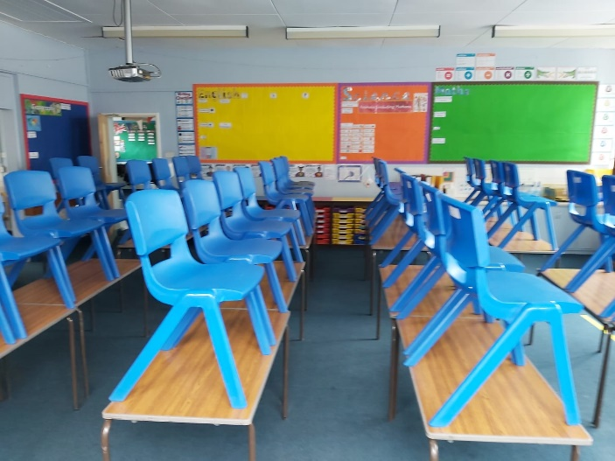
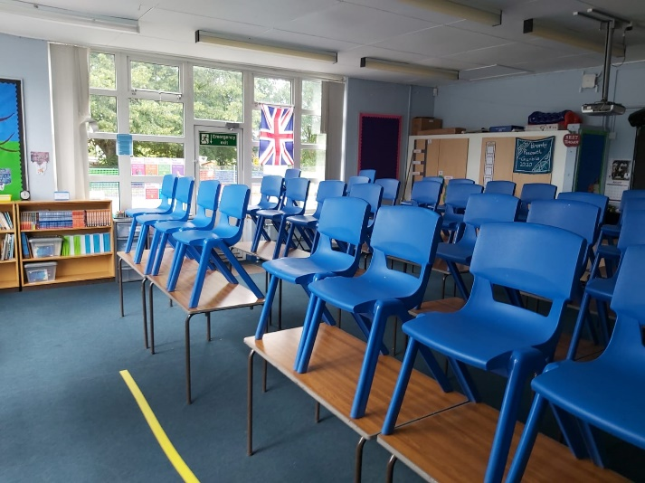
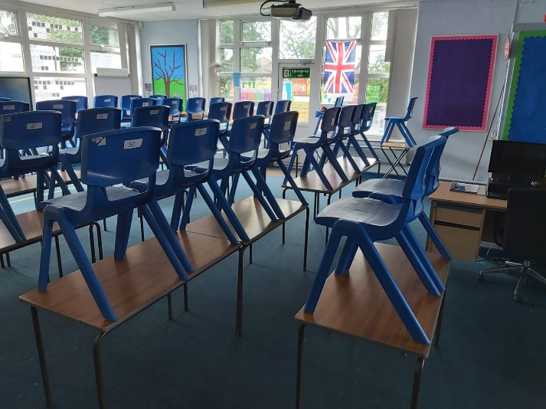

Year 6 Curriculum
Maths – Our first maths unit is going to be place value, where we will be recapping the place value of numbers to ten million.
English – We are going to be looking at writing some ghost stories for our first unit of work.
Reading – In reading we will be using the VIPERS to help us understand and talk about books. The VIPERS stand for Vocabulary, Infer, Predict, Explain, Retrieve and Summarise. Our first, class book will be -
Humanities – In the first half-term we will be looking at World Mapping.
Science – We will be looking at Animals including Humans, as our first science unit this year.
Art – We are starting the year by looking at self-portraits, whilst exploring the work of Julian Opie.
RE – We are going to be looking at the Beliefs and Practices in various world religions.

Daily Routine

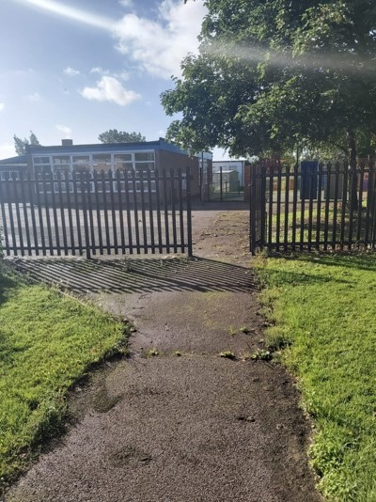
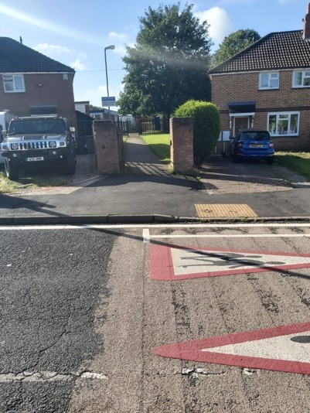
- Children will enter the site independently form the Heydon Road gate at 0840 and line up in designated areas, outside their classrooms. Parents of children in Years 4, 5 and 6 will not be able to enter the site. We ask that parents keep the entrances clear so that children may enter safely.
- Enter the classroom ready to complete the morning reading time. You will also be washing your hands/ using the hand sanitiser during this time;
- Lesson 1 – Spellings/ Phonics
- Lesson 2 – Maths
- Lesson 3 – English (Writing)
- Lesson 4 – English (Reading)
- Lesson 5 – one of the following subjects: Science, History, Geography, Art, Music, SMSC, RE, PE.
- School ends at 3:20pm. You will leave the classroom through the fire exit door using the hand sanitiser on your way out. You will be taken to the gate at Heydon Road to meet your parents.

